F – Intento de Transacción de Combustible Incorrecto
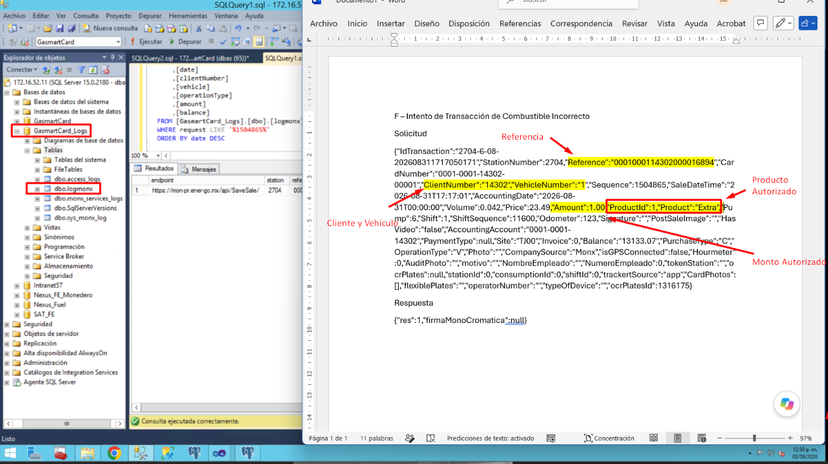
Solicitud
{"IdTransaction":"2704-6-08-202608311717050171","StationNumber":2704,"Reference":"0001000114302000016894","CardNumber":"0001-0001-14302-00001","ClientNumber":"14302","VehicleNumber":"1","Sequence":1504865,"SaleDateTime":"2026-08-31T17:17:01","AccountingDate":"2026-08-31T00:00:00","Volume":0.042,"Price":23.49,"Amount":1.00,"ProductId":1,"Product":"Extra","Pump":6,"Shift":1,"ShiftSequence":11600,"Odometer":123,"Signature":"","PostSaleImage":"","HasVideo":"false","AccountingAccount":"0001-0001-14302","PaymentType":null,"Site":"TJ00","Invoice":0,"Balance":"13133.07","PurchaseType":"C","OperationType":"V","Photo":"","CompanySource":"Monx","isGPSConnected":false,"Hourmeter":0,"AuditPhoto":"","motivo":"","NombreEmpleado":"","NumeroEmpleado":0,"tokenStation":"","ocrPlates":null,"stationId":0,"consumptionId":0,"shiftId":0,"trackertSource":"app","CardPhotos":[],"flexiblePlates":"","operatorNumber":"","typeOfDevice":"","ocrPlatesId":1316175}
Respuesta
{"res":1,"firmaMonoCromatica":null}

